General Guidelines for Media Interviews

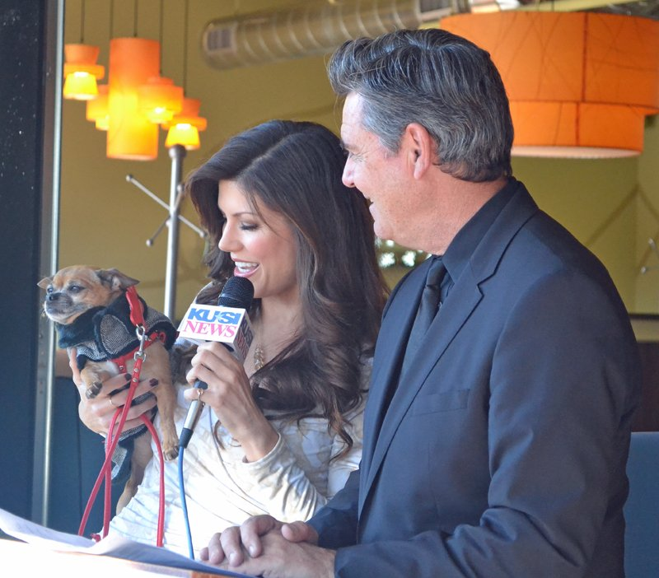

Media interviews can be easy for some people and very difficult for others. The key to an effective interview is preparation. If you are prepared, you have nothing to be nervous about.

1st Step – How to Prepare For Your Interview
Just as you expect a reporter to do his or her homework before interviewing you, it is appropriate for you to prepare for an interview with a reporter.
- Find out the reporter or host’s name and purpose of the story or show.
- Help the reporter do his preparation by providing background information prior to the interview. This might include a fact sheet about your organization, a fact sheet about your upcoming event and/or a general fact sheet about the Home 4 the Holidays Campaign. Be sure to let them know the name, title and contact information of the person they will be talking to, as well.
- Anticipate probable questions and practice your responses before the interview.
- Decide on one or two short, key messages that accurately explain your involvement in Home 4 the Holidays, and your goals. Practice this statement and have it ready when asked about the program.

It is important to remember that a reporter is always concerned about how the interview will relate to the audience. By understanding the reporter’s concern, you will be able to cooperate so the interview is a successful experience for both of you.

2nd Step – Types of Interviews

Print Interviews
A print interview for a newspaper or magazine story is generally longer in length than a television or radio interview. This increased time frame enables you to more fully develop the messages you wish to communicate. However, the print interview necessitates more detailed examples and requires an in-depth knowledge of your subject matter.
The following will help you to prepare for your print interview:
- It is common for a reporter to use a tape recorder. Don’t let it unnerve you; it increases your chances of being quoted correctly.
- Be sure the reporter knows where he can reach you in case he needs additional information while writing the story.
- If a reporter writes a story, which seriously misrepresents the facts, contact the publication’s editor and ask for a correction.
- Don’t complain about minor slips in an otherwise accurate story.

Reporters often make a telephone call to ask for a quick quote to balance a story. If you are called, remember you are under no obligation to answer immediately. Ask the reporter what his deadline is and promise to get back to him with a response. Return the call only after you feel confident of your position and the facts. However, it is imperative to respect the reporter’s deadline.
If you are asked a question that should be answered from a different perspective, refer the reporter to the appropriate source.

Radio Interviews
Radio interviews allow you to address an audience personally. On radio the audience depends solely upon your voice to develop a perception of you and your message, so your voice is your most important tool. Begin your interview with high energy and strength in your first statement. Be friendly and conversational but make sure you sound professional and knowledgeable, as well.
The following techniques can improve your radio interview:
- Be sure to select a key player from your organization for this interview.
- Sometimes, an interviewer will ask an unexpected question. The more knowledgeable your spokesperson, the better likelihood he/she will be able to respond easily with correct information.
- Because the interview will be heard, rather than seen, it is appropriate to bring notes.
- Be sure to glance at notes without rustling them around. This can be heard on the radio and it is important to give the impression that you are speaking off the cuff.
- Smiling automatically makes you sound friendlier. Be sure to smile when you greet the host at the beginning of the interview and thank the host at the end of the interview.

Television Broadcast Interviews
Television interviews also allow you to address an audience personally. Your voice is an equally important tool for television interviews but, because television is a visual medium, your appearance is often as important as what you say.
You may participate in live or taped news segments or talk show interviews. In a “taped” news interview, NO ONE IS WATCHING. Comments will be edited and only portions of your answers will be used. In a 10-minute taped interview, you may discover less than a minute of footage actually is used in the final story. Therefore, it is critical to deliver messages concisely and with energy. Television news thrives on strongly delivered segments.
During a “live” news interview, everything you say and do will be seen in the moment. Make sure your selected spokesperson is normally relaxed and confident when speaking about your organization and your mission.
The following techniques can improve your appearance on television:
- Be sure to dress professionally and stay away from bold patterns or anything black or white.
- Keep hair pinned away from your face.
- Ask if you can bring one of your available adoptables on camera with you. (Make sure your orphan pet is well groomed, well behaved and wearing an eye-catching bow or scarf.)
- Sitting erect and leaning slightly forward in your chair gives the impression that you are alert and in control of the situation.
- STAY POSITIVE! Never speak negatively about another organization or program. Just stay focused on your own message.
- Know your material. You should not bring notes to a TV interview, so be sure you know your material backwards and forwards. Practice the things you want to say about your organization, your event and the Home 4 the Holidays campaign.
- Speak to the interviewer, NOT to the camera.
- Smile and establish eye contact with your interviewer.
- Relax.

One final point to remember: after the interviewer completes the questioning and thanks the audience for tuning in, you may remain on the air for a few minutes, such as when end-of-show credits are superimposed over the picture. Be sure to maintain your “presence” until you are told you are no longer on air.

